**AMERICAN INTERNATIONAL UNIVERSITY BANGLADESH**

**Faculty of Engineering**

**Laboratory Report Cover Sheet**

Please submit all reports to your subject supervisor or the office of the concerned faculty.

***Students must complete all details except the faculty use part.***

|  |
| --- |
| Laboratory Title: Implementation of a weather forecast system using the ADC modules of an Arduino.  Experiment Number: 08 Due Date: Semester: Fall 2023-2024  Subject Code: COE 3104 Subject Name: Microprocessor & Embedded System Section: L  Course Instructor: PROTIK PARVEZ SHEIKH Degree Program: _ B.sc CSE |

**Declaration and Statement of Authorship:**

1. I/we hold a copy of this report, which can be produced if the original is lost/ damaged.
2. This report is my/our original work and no part of it has been copied from any other student’s work or from any other source except where due acknowledgement is made.
3. No part of this report has been written for me/us by any other person except where such collaboration has been authorized by the lecturer/teacher concerned and is clearly acknowledged in the report.
4. I/we have not previously submitted or currently submitting this work for any other course/unit.
5. This work may be reproduced, communicated, compared and archived for the purpose of detecting plagiarism.
6. I/we give permission for a copy of my/our marked work to be retained by the School for review and comparison, including review by external examiners.

**I/we understand that**

1. Plagiarism is the presentation of the work, idea or creation of another person as though it is your own. It is a form of cheating and is a very serious academic offence that may lead to expulsion from the University. Plagiarized material can be drawn from, and presented in, written, graphic and visual form, including electronic data, and oral presentations. Plagiarism occurs when the origin of the material used is not appropriately cited.

Group Number (if applicable): Individual Submission Group Submission



|  |  |  |  |  |  |  |
| --- | --- | --- | --- | --- | --- | --- |
| **No.** | **Student Name** | | **Student ID** | **Student Signature** | **Date** | |
| **Submitted by:** | | |  |  |  | |
| **1** | TAZUDDIN AHMAD | | 20-42787-1 | Tazuddin |  | |
| **Group Members:** | | |  |  |  | |
| **2** | MD. IMRAN AHMED | | 20-43738-2 | Imran |  | |
| **3** | TANVIR HASAN TAMAL | | 21-44626-1 | Tamal |  | |
| **4** | NOKIBUL ARFIN SIAM | | 21-44793-1 | Siam |  | |
| **5** | MD. ZAMIUL SADIK NAHIN | | 20-44228-3 | Nahin |  | |
| ***For faculty use only:***    **Faculty comments** | | **Total Marks: Marks Obtained:** | | | |
|  | | | |

**Title:**

Implementation of a weather forecast system using the ADC modules of an Arduino.

**Objectives:**

The objectives of this experiment are to-

1. Familiarize the students with the Micro-controller-based weather forecast system
2. Implement the environmental parameters, such as temperature, pressure and humidity..

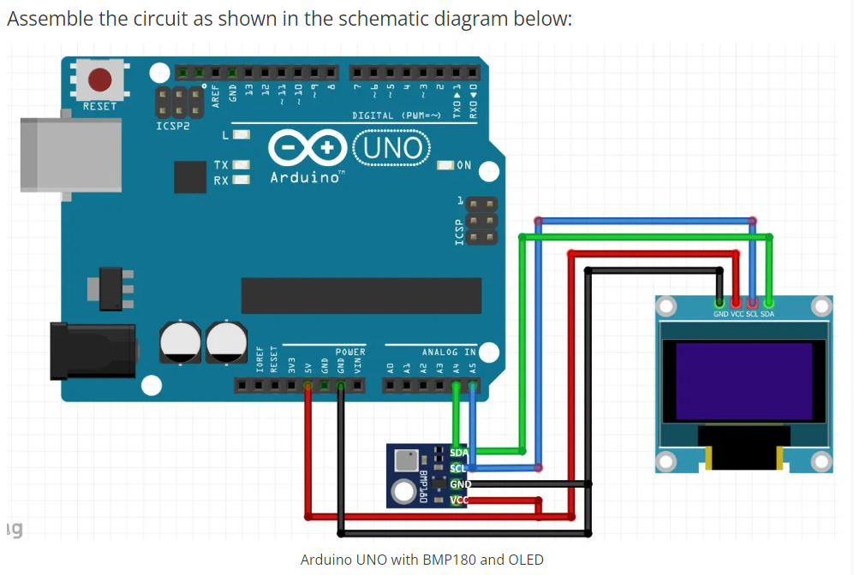

Figure 2. Arduino Uno with BMP180 and OLED

**Components List**

* Arduino Uno Board
* BMP180 / MPL115A
* inches96 inch OLED 128X64
* Breadboard and Jump Wires

**Code:**

#include <SPI.h>

#include <Wire.h>

#include <Adafruit_GFX.h>

#include <Adafruit_SSD1306.h>

#include <Adafruit_BMP085.h>

#define SCREEN_WIDTH 128

#define SCREEN_HEIGHT 64

Adafruit_SSD1306 display(SCREEN_WIDTH, SCREEN_HEIGHT);

Adafruit_BMP085 bmp;

#define SEALEVELPRESSURE_PA (101500)

float simpleweatherdifference, currentpressure, predictedweather, currentaltitude;

void setup() {

*// put your setup code here, to run once:*

display.begin(SSD1306_SWITCHCAPVCC, 0x3C);

if (!bmp.begin()) {

Serial.println("Could not find a valid BMP085 sensor, check wiring!");

while (1) {}

}

}

void loop() {

display.clearDisplay();

display.setTextSize(1);

display.setTextColor(SSD1306_WHITE);

display.setCursor(0,5);

display.print("BMP180");

display.setCursor(0,19);

display.print("T=");

display.print(bmp.readTemperature(),1);

display.println("*C");

display.setCursor(0,30);

display.print("P=");

display.print(bmp.readPressure()/100.0,1);

display.println("hPa");

display.setCursor(0,40);

display.print("A=");

display.print(bmp.readAltitude(SEALEVELPRESSURE_PA),1);

display.println("m");

delay(6000);

display.display();

currentpressure=bmp.readPressure()/100.0;

**currentaltitude=bmp.readAltitude(SEALEVELPRESSURE_PA);**

predictedweather=(101.3*exp(((float)(currentaltitude))/(-7900)));

simpleweatherdifference=currentpressure-predictedweather;

*//display.clearDisplay();*

display.setCursor(0,50);

if (simpleweatherdifference>0.25)

display.print("SUNNY");

if (simpleweatherdifference<=0.25)

display.print("SUNNY/CLOUDY");

if (simpleweatherdifference<-0.25)

display.print("RAINY");

display.display();

delay(2000);

}

**Hardware Implemantation:**

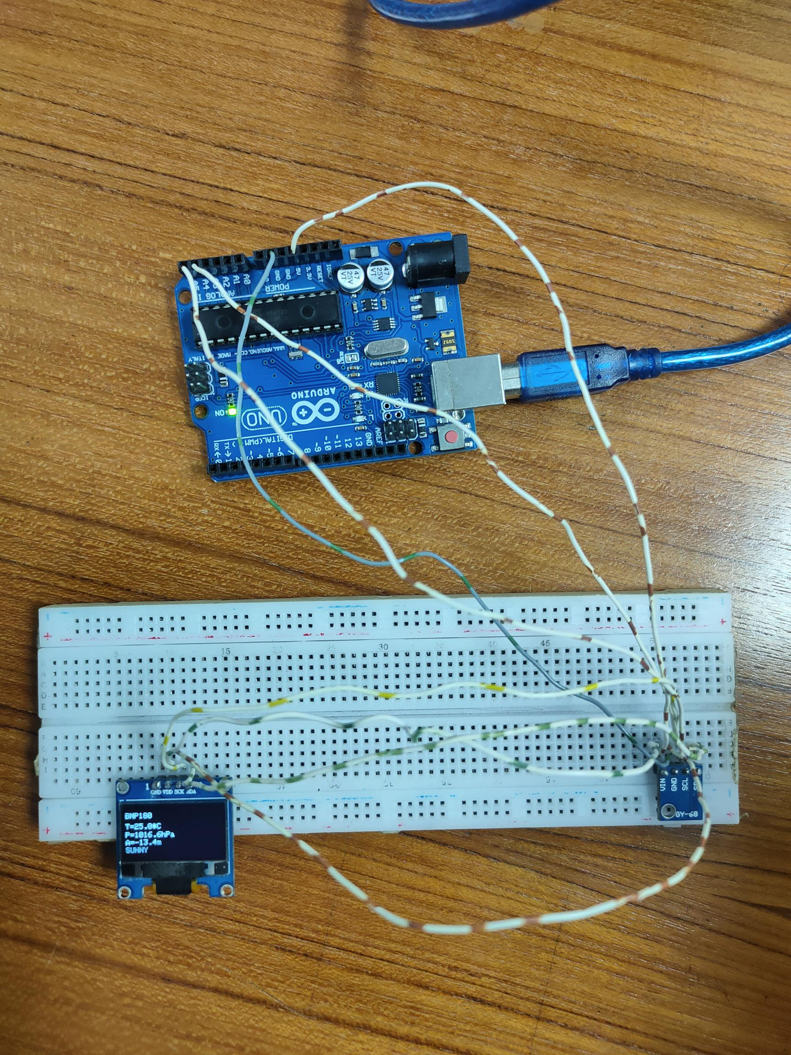

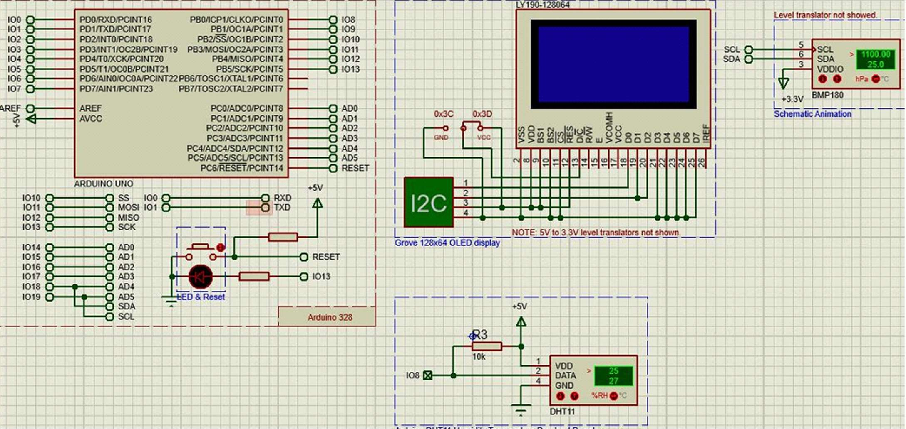

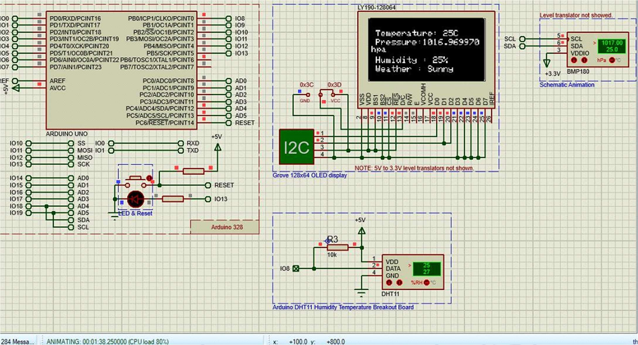

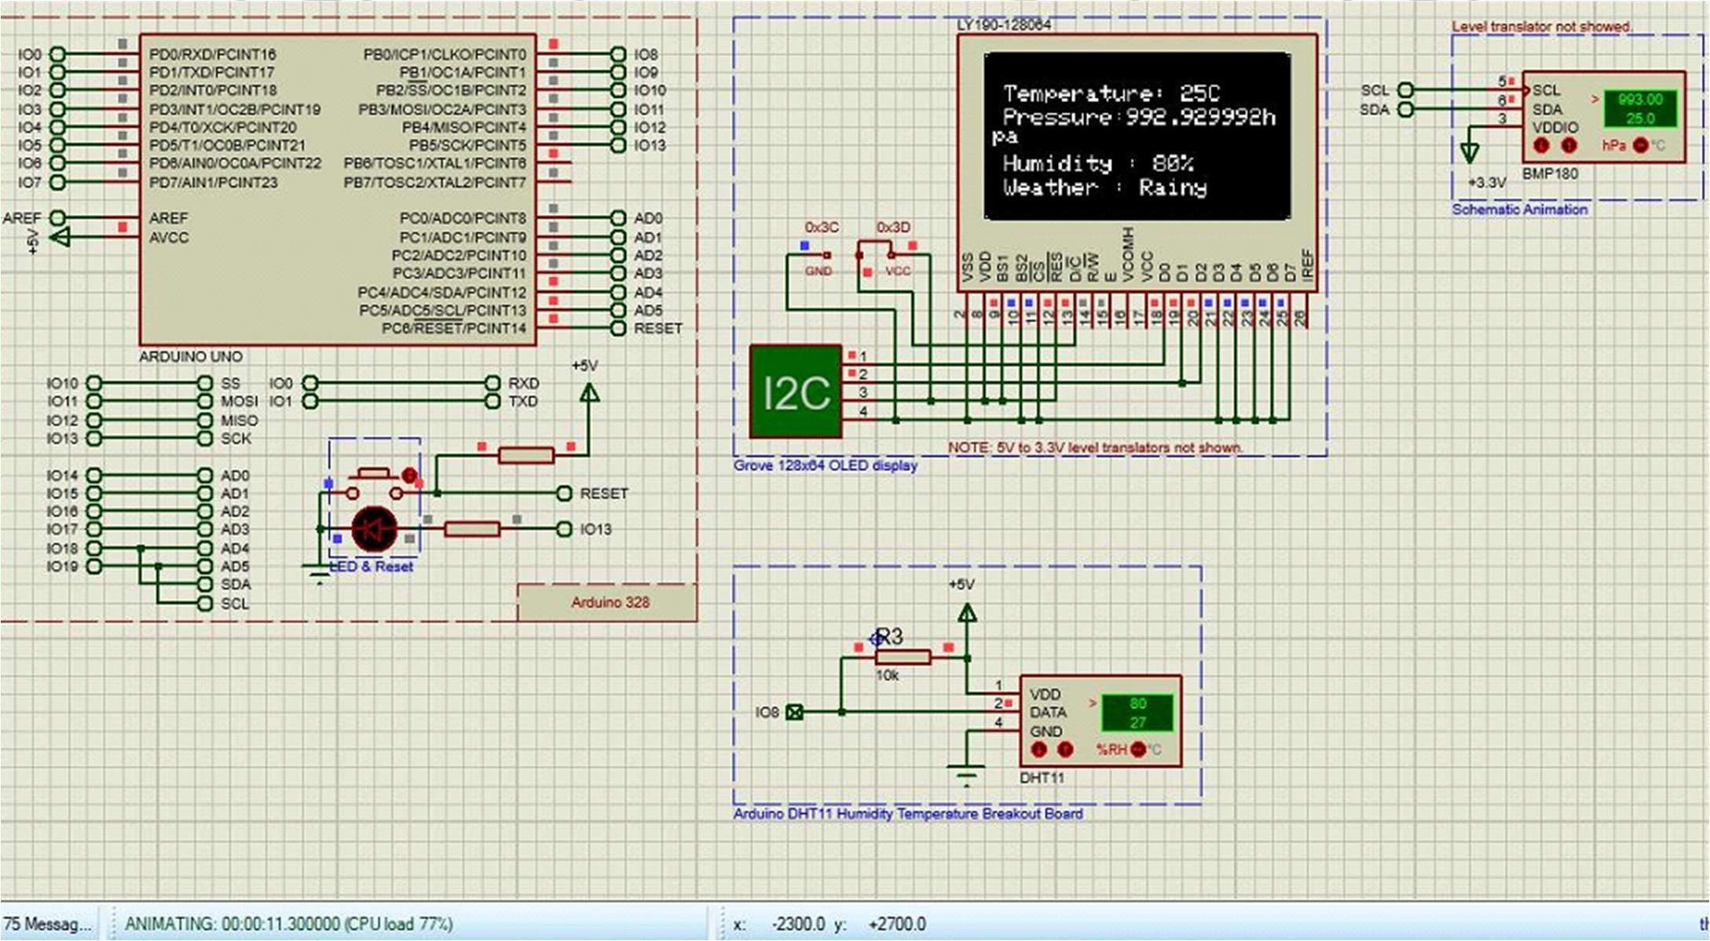

**Discussion:**

In this experiment, the BMP180 sensor was employed to measure temperature, pressure, and altitude, with the collected data displayed on an OLED screen connected through ADC. Prior to implementation, a thorough understanding of the BMP180 sensor's pin operations and functionality was gained. The Arduino Uno board was configured to match the BMP180 sensor, and the OLED display was set up accordingly. System operations were observed, focusing on how weather conditions were determined through temperature and pressure readings. The results, generated using predefined formulas in the code, were diligently recorded for further analysis. A parallel system was also simulated using software like Proteus. Minor discrepancies between the physical and simulated outcomes were noted, potentially stemming from system and human errors, leading to inconsistencies in the serial monitor values. Despite these differences, both hardware and software implementations yielded expected outcomes, demonstrating successful achievement of the experimental objectives.

**Reference:**

* (<https://www.youtube.com/watch?v=M4f4ntzgkv4>
* AIUB Microprocessor and Embedded Systems Lab Manual 8